**Chapter 1**

**COMPANY INFORMATION**

Accolade Tech Solutions is one of the renowned software and web development company. The headquarters is situated in Mangaluru, India. Accolade Tech Solutions is well recognized for its innovative approach towards delivering business value and its commitment to sustainability. Accolade Tech Solutions helps customers to do business better leveraging our industry-wide experience, deep technology expertise, comprehensive portfolio of services and a vertically aligned business model. Dedicated emerging technologies enabled to harness the latest technology for delivering business capability to their clients. In short, Accolade Tech Solutions is an all-encompassing service provider, within 6 years of its successful run in providing valuable services in the business & IT sector.

* 1. **Introduction of the Organization**

Accolade Technology Solutions is one of the well renowned IT company in the Mangaluru which focuses on advising organizations on how best to use Information Technology in achieving business objectives. An opportunity for the employees to expand their knowledge, skill and abilities which help in bringing satisfaction among the employees has been provided. Meanwhile also deal in meeting the expectation of the customers hence creating a long term value for an organization from customers and markets.

**1.2 About the Founder**

Harish Neermarga is the experienced Chief Executive Officer with a demonstrated history of working in the information technology and services industry and is Skilled in Machine Learning, Android and IOS mobile application development, Website Design and Software Development. Strong business development professional with a Master of Computer Applications - MCA focused in Information Technology from Manipal Institute of Technology.

**1.3 Vision and Mission**

Vision: To spread the use of IT and related support expertise to right people with right technology among a wider client base.

Mission: To create dynamic and seamlessly integrated service solutions for managing customer contacts, orders, and international service fulfilment and enabling clients to introduce new products and business.

**1.4 Policies**

Karnataka Chamber of Commerce has been admitted as a member of Kanara Chamber of Commerce Industry, Mangalore in the year 2016 - 2017 and is entitled to all the privileges of membership as set forth in the articles of association of the chamber.

**1.5 Organizational Structure**

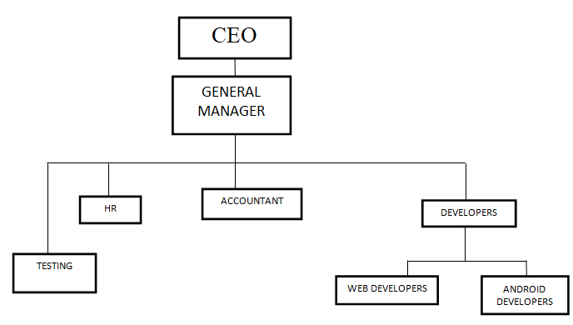

***Figure 1.1****: Organizational structure*